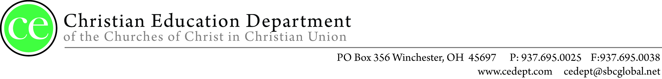
Dear Church Leader,
The CE Department would like to take this opportunity to invite you, your church’s teachers, and children’s workers to the 2024 Teacher Appreciation Dinner. The Christian Education Department holds this banquet once a year in order to say “Thank You” for the countless hours of ministry promoting Christian Education throughout our denomination.
This year’s banquet will be held at Heritage Church in Washington Court House, Ohio on March 16, 2024. The dinner will begin at 4:30 pm in the Fellowship Hall and will be followed by a time of praise and worship at 6:00pm with our special guest The Joneses. During this time special presentations and awards will be given for this year’s “Outstanding Teacher”. We ask that you take a few moments and fill out the enclosed form to nominate outstanding teachers and workers from your church so that they may be recognized for their dedication.
If you or others from your church wish to attend, please complete and return the form attached below along with your registration fee. Individuals must register and have a ticket in order to attend the dinner; the concert is free of charge.
Alternatively you may register online by going to www.cedept.com
Registration fees for the banquet:
$25.00 for 10 teachers/workers
$35.00 for 20 teachers/workers
$50.00 for 30 or more teachers/workers
The deadline for registration is March 2,2024.
_ _ _ _ _ _ _ _ _ _ _ _ _ _ _ _ _ _ _ _ _ _ _ _ _ _ _ _ _ _ _ _ _ _ _ _ _ _ _ _ _ _ _ _ _ _ _ _ _ _ __ _ _ _ _ _ _ _ _ _ _ _ _ _ _ _ _ _ _ _ _ _ _ _ _ _ _ _ _ _ _
Appreciation Dinner Reply Form
(please fill this out and return it to the CE Department by March 2, 2024)
Send it to: Churches of Christ in Christian Union
c/o CE Dept
1553 Lancaster Pike
Circleville, Ohio 43113
Name of Church: __________________________________________________________________________________________
Your Name: ______________________________________________ Position: _______________________________________
Number of Tickets Requested:__ ________ Phone number: ____________________________________________________
Your address:_____________________________________________________________________________________________
__________________________________________________________________________________________________________
SS TEACHER/WORKER OF THE YEAR
NOMINEE FORM
Church Name: ___________________________________________________________________________________________
Your Name:______________________________________________________________________________________________
Name of Nominee:________________________________________________________________________________________
Number of years teaching/working: _______________________
Grade level the nominee is teaching:
Nursery Elementary Jr High
Sr High College & Career Young Adult
Senior Adult Other _______________________
Why have you nominated this person?
________________________________________________________________________________________________________________________________________________________________________________________________________________________________________________________________________________________________________________________________________________________________________________________________________________________________________
Accomplishments of this individual:
________________________________________________________________________________________________________________________________________________________________________________________________________________________________________________________________________________________________________________________________________________________________________________________________________________________________________

-Please complete this form and return it to the following address:
CE Department PO Box 356 Winchester OH 45697
-you can also email to 3cucedept@gmail.com-

