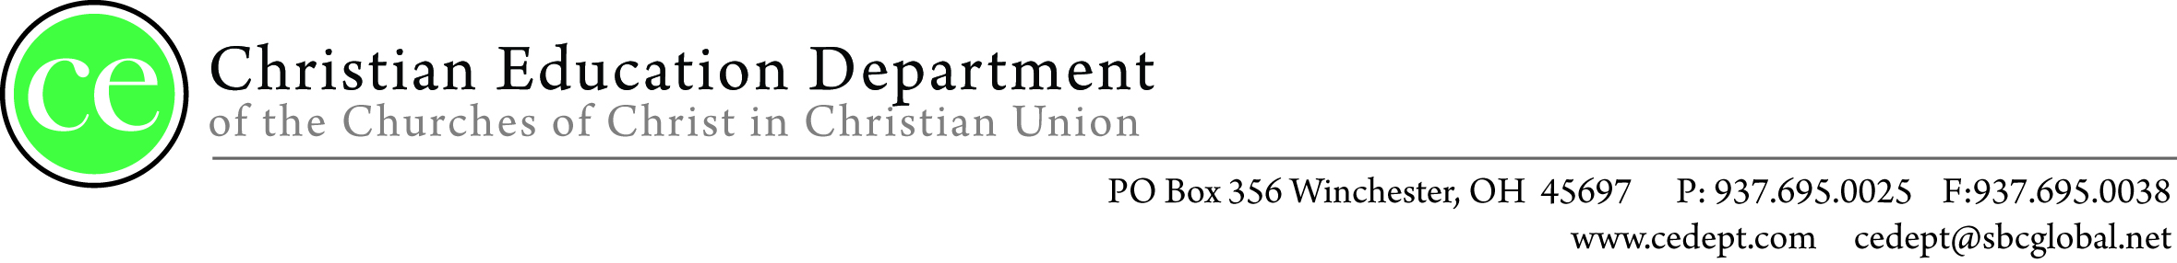
January 24, 2017

Greetings from the CE Dept,
We would like to take this opportunity to invite you, your church’s teachers, and children’s workers to the 2017 Teacher Appreciation Dinner. The Christian Education Department holds this banquet once a year in order to say “Thank You” for the countless hours of ministry promoting Christian Education throughout our denomination.
This year’s banquet will be held at Heritage Memorial Church in Washington Court House, Ohio on March 11, 2017. The dinner will begin at 4:30pm in the Fellowship Hall and will be followed by a FREE concert at 6:00pm with our special guest The Martins. During this time special presentations and awards will be given for this year’s “Outstanding Teacher”. We ask that you take a few moments and fill out the enclosed form to nominate outstanding teachers and workers from your church so that they may be recognized for their dedication.
If you or others from your church wish to attend, please complete and return the form attached below along with your registration fee. Individuals must register and have a ticket in order to attend the dinner; the concert is free of charge.
Alternatively you may register online by going to www.cedept.com
Registration fees for the banquet:
$5.00 for Individuals
$25.00 for 10 teachers/workers
$35.00 for 20 teachers/workers
$50.00 for 30 or more teachers/workers
The deadline for registration is March 06, 2017.
_ _ _ _ _ _ _ _ _ _ _ _ _ _ _ _ _ _ _ _ _ _ _ _ _ _ _ _ _ _ _ _ _ _ _ _ _ _ _ _ _ _ _ _ _ _ _ _ _ _ _
Appreciation Dinner Reply Form
(please fill this out and return it to the CE Department by March 06, 2017)
Send it to: Churches of Christ in Christian Union c/o Bruce A. Crabtree
1553 Lancaster Pike Circleville, Ohio 43113
Name of Church: _______________________________________________
Your Name: _____________________ Position: ______________________
Number of Tickets Requested:__ _____ Phone number: _________________
Your address (where to send the tickets): ____________________________________________________________
____________________________________________________________
SS TEACHER/WORKER OF THE YEAR
NOMINEE FORM
Church Name: ________________________________________________
Your Name:___________________________________________________
Name of Nominee:______________________________________________
Number of years teaching/working: _____________
Grade level the nominee is teaching:
Nursery Elementary Jr High
Sr High College & Career Young Adult
Senior Adult Other _______________________
Why have you nominated this person?
_______________________________________________________________________________________________________________________________________________________________________________________________________________________________________________________________________________________________________________________________________________________________________
Accomplishments of this individual:
________________________________________________________________________________________________________________________________________________________________________________________________________________________________________________________________________________________________________________________________________________________________________
Please complete this form and return it to the following address:

Please complete this form and return it to the following address:
CE Department PO Box 356 Winchester OH 45697

